Project: EHR SOFA — prediction of mortality among ventilated

Sensitivity analysis, excluded patients with ESRD at admission

October 27, 2021

## Conditional Tree

### SOFA + all components

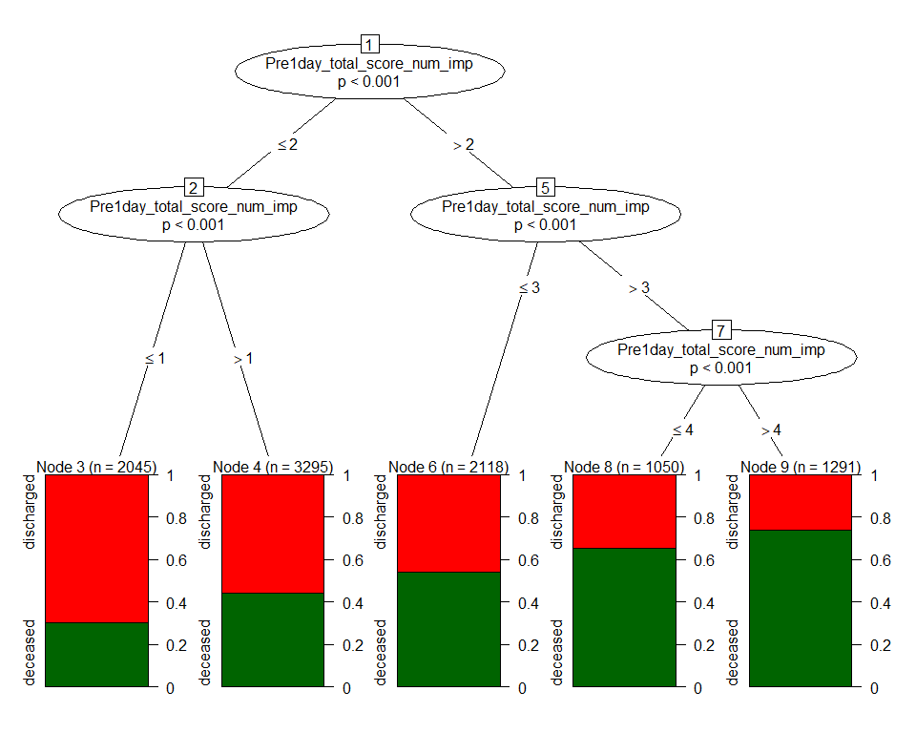

|  |  |  |
| --- | --- | --- |
| Variable | AUC.train | AUC.test |
| SOFA + all components | 0.654 (0.644,0.665) | 0.655 (0.64,0.67) |

### SOFA alone



|  |  |  |
| --- | --- | --- |
| Variable | AUC.train | AUC.test |
| SOFA | 0.654 (0.644,0.665) | 0.655 (0.64,0.67) |

### Categorical SOFA alone

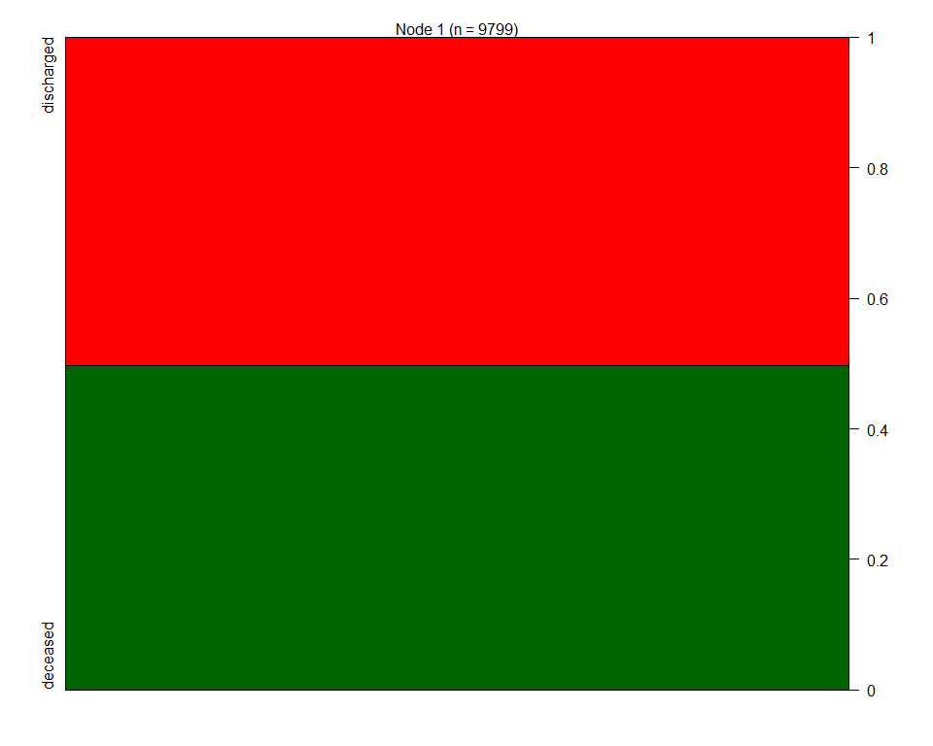

|  |  |  |
| --- | --- | --- |
| Variable | AUC.train | AUC.test |
| SOFA categories | 0.5 (0.5,0.5) | 0.5 (0.5,0.5) |

### Pulmonary sofa alone

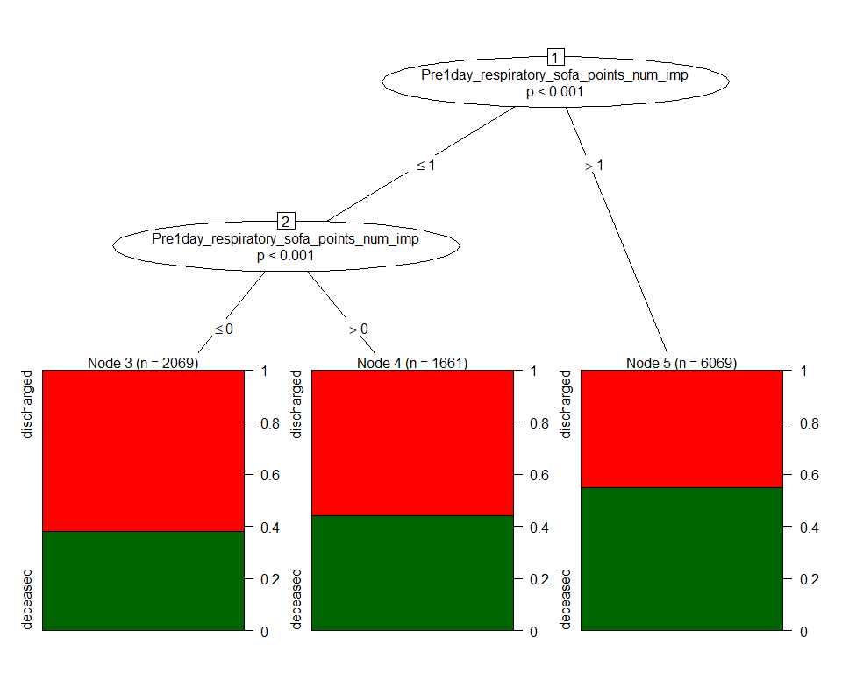

|  |  |  |
| --- | --- | --- |
| Variable | AUC.train | AUC.test |
| Pulmonary | 0.572 (0.562,0.582) | 0.582 (0.568,0.596) |

### Renal sofa alone



|  |  |  |
| --- | --- | --- |
| Variable | AUC.train | AUC.test |
| Renal | 0.5 (0.5,0.5) | 0.5 (0.5,0.5) |

### Heme sofa alone

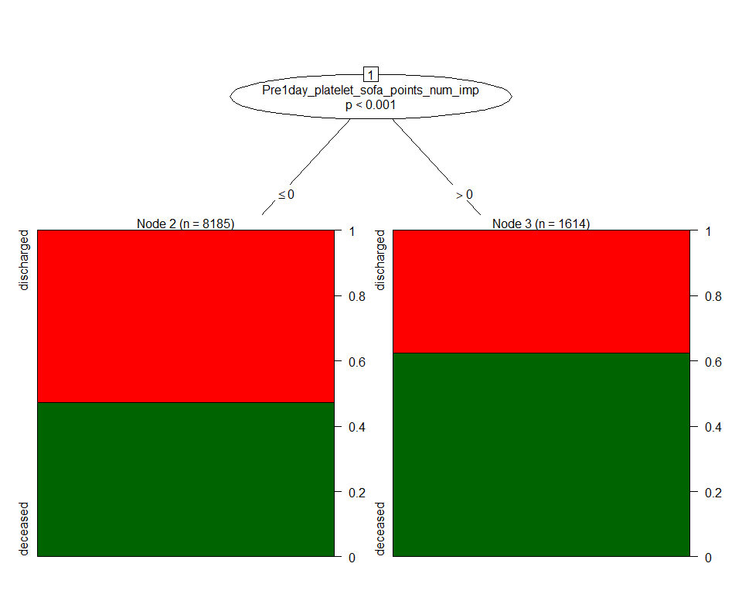

|  |  |  |
| --- | --- | --- |
| Variable | AUC.train | AUC.test |
| Heme | 0.542 (0.534,0.549) | 0.533 (0.522,0.544) |

### Neuro sofa alone

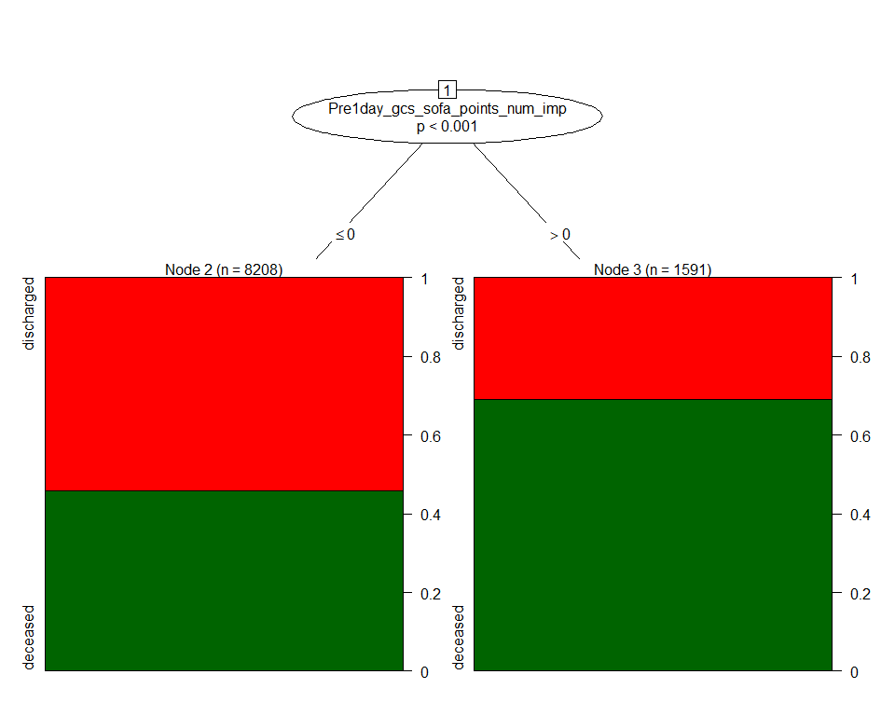

|  |  |  |
| --- | --- | --- |
| Variable | AUC.train | AUC.test |
| Neuro | 0.563 (0.556,0.57) | 0.566 (0.555,0.576) |

### Liver sofa alone

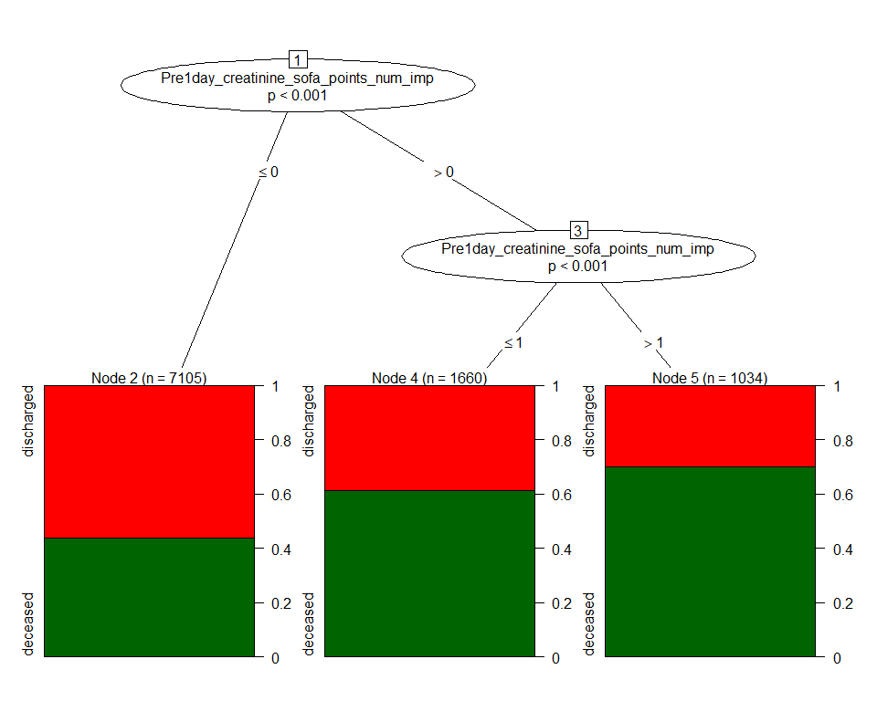

|  |  |  |
| --- | --- | --- |
| Variable | AUC.train | AUC.test |
| Liver | 0.586 (0.577,0.595) | 0.58 (0.567,0.592) |

### Cardio sofa alone

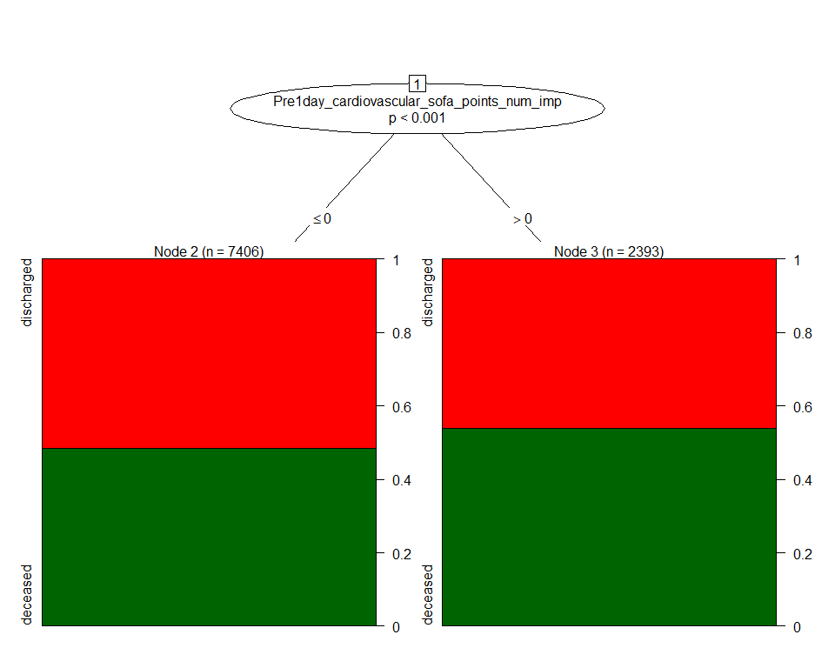

|  |  |  |
| --- | --- | --- |
| Variable | AUC.train | AUC.test |
| Cardio | 0.521 (0.512,0.529) | 0.521 (0.509,0.533) |

### SOFA + all components + age + gender + obesity +diabetes + hypertension

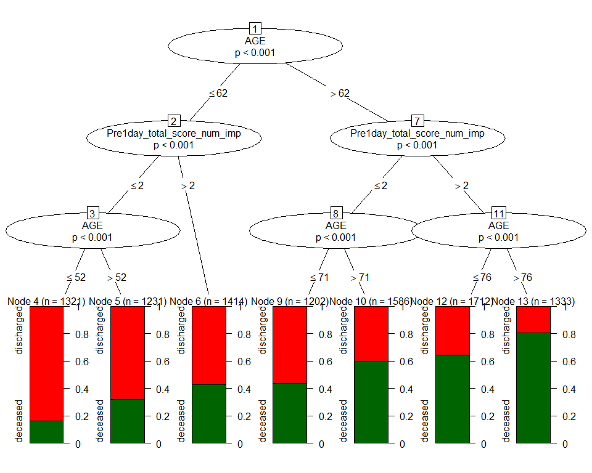

|  |  |  |
| --- | --- | --- |
| Variable | AUC.train | AUC.test |
| SOFA & all components + covariates | 0.72 (0.71,0.73) | 0.713 (0.698,0.727) |

### SOFA + age + gender + obesity +diabetes + hypertension



|  |  |  |
| --- | --- | --- |
| Variable | AUC.train | AUC.test |
| SOFA + covariates | 0.72 (0.71,0.73) | 0.713 (0.698,0.727) |

### Pulmonary sofa + age + gender + obesity +diabetes + hypertension

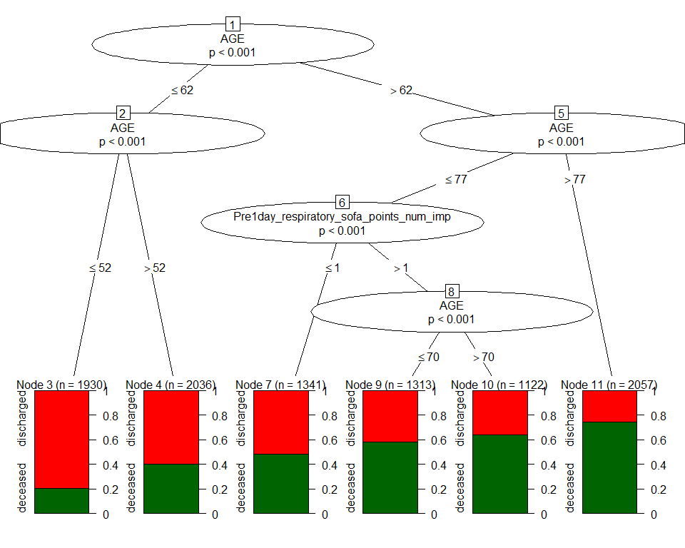

|  |  |  |
| --- | --- | --- |
| Variable | AUC.train | AUC.test |
| Pulmonary sofa + covariates | 0.709 (0.699,0.719) | 0.706 (0.692,0.72) |

### Renal sofa + age + gender + obesity +diabetes + hypertension

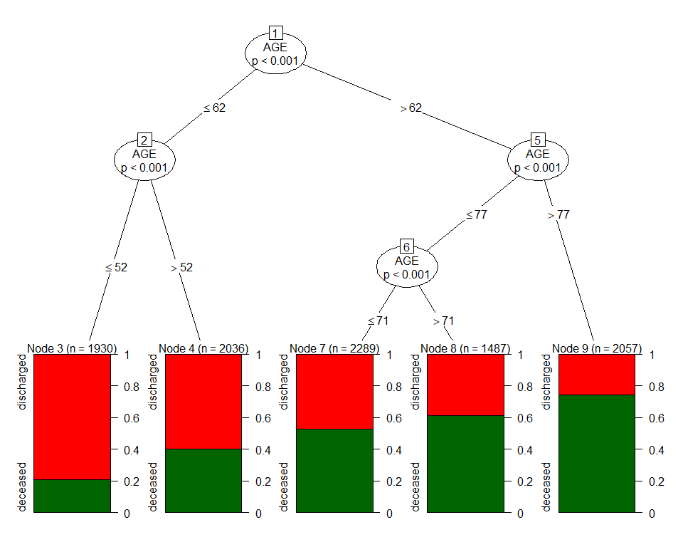

|  |  |  |
| --- | --- | --- |
| Variable | AUC.train | AUC.test |
| Renal sofa + covariates | 0.705 (0.695,0.715) | 0.701 (0.687,0.715) |

### Heme sofa + age + gender + obesity +diabetes + hypertension



|  |  |  |
| --- | --- | --- |
| Variable | AUC.train | AUC.test |
| Heme sofa + covariates | 0.705 (0.695,0.715) | 0.701 (0.687,0.715) |

### Neuro sofa + age + gender + obesity +diabetes + hypertension



|  |  |  |
| --- | --- | --- |
| Variable | AUC.train | AUC.test |
| Neuro sofa + covariates | 0.705 (0.695,0.715) | 0.701 (0.687,0.715) |

### Liver sofa + age + gender + obesity +diabetes + hypertension

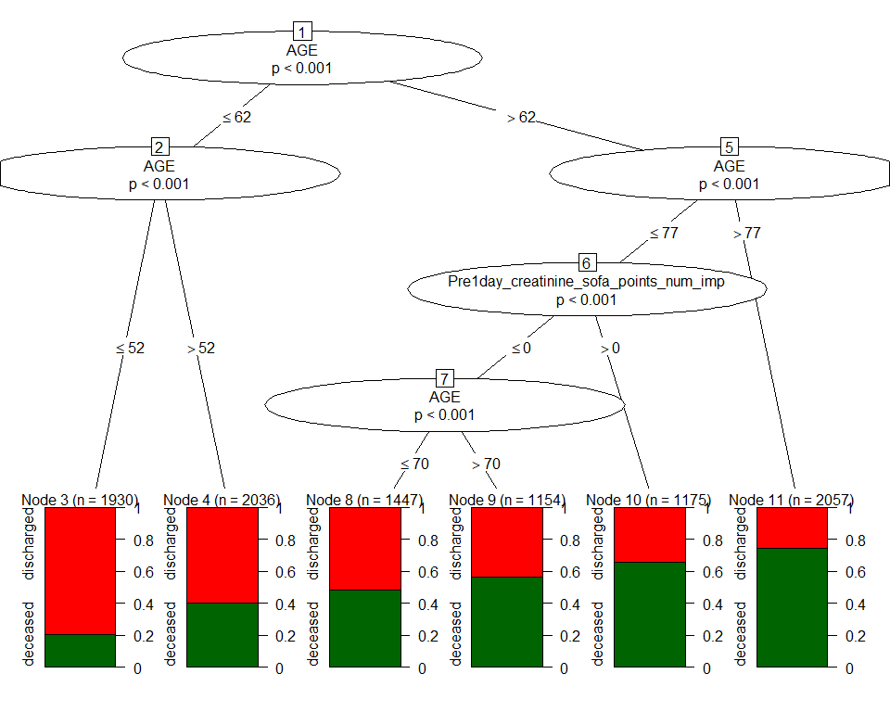

|  |  |  |
| --- | --- | --- |
| Variable | AUC.train | AUC.test |
| Liver sofa + covariates | 0.71 (0.7,0.72) | 0.706 (0.692,0.72) |

### Cardio sofa + age + gender + obesity +diabetes + hypertension



|  |  |  |
| --- | --- | --- |
| Variable | AUC.train | AUC.test |
| Cardio sofa + covariates | 0.705 (0.695,0.715) | 0.701 (0.687,0.715) |

### age



|  |  |  |
| --- | --- | --- |
| Variable | AUC.train | AUC.test |
| age | 0.705 (0.695,0.715) | 0.701 (0.687,0.715) |

### age + SOFA



|  |  |  |
| --- | --- | --- |
| Variable | AUC.train | AUC.test |
| age + SOFA | 0.72 (0.71,0.73) | 0.713 (0.698,0.727) |

### age + Categorical SOFA



|  |  |  |
| --- | --- | --- |
| Variable | AUC.train | AUC.test |
| age + Categorical SOFA | 0.705 (0.695,0.715) | 0.701 (0.687,0.715) |

### age + elixhauser score



|  |  |  |
| --- | --- | --- |
| Variable | AUC.train | AUC.test |
| age + elixhauser score | 0.705 (0.695,0.715) | 0.701 (0.687,0.715) |

### age + gender + obesity +diabetes + hypertension



|  |  |  |
| --- | --- | --- |
| Variable | AUC.train | AUC.test |
| covariates | 0.705 (0.695,0.715) | 0.701 (0.687,0.715) |

### SOFA + elixhauser score



|  |  |  |
| --- | --- | --- |
| Variable | AUC.train | AUC.test |
| SOFA + elixhauser score | 0.654 (0.644,0.665) | 0.655 (0.64,0.67) |

### Categories SOFA + elixhauser score

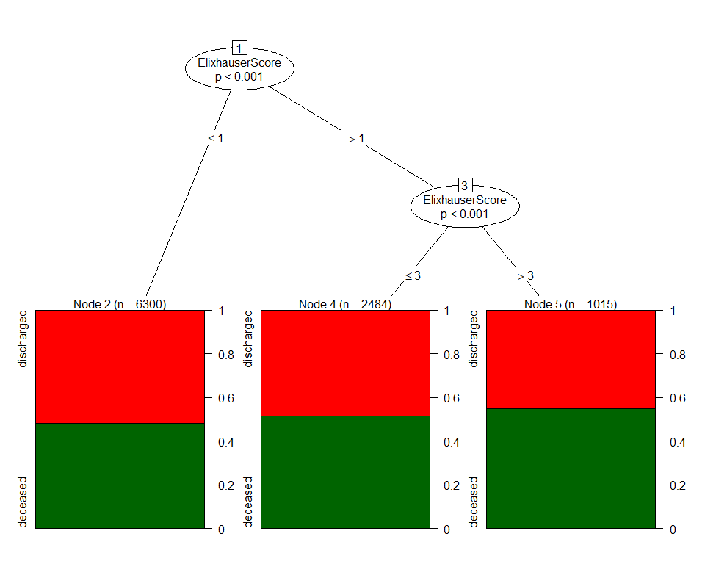

|  |  |  |
| --- | --- | --- |
| Variable | AUC.train | AUC.test |
| Categories SOFA + elixhauser score | 0.522 (0.513,0.532) | 0.52 (0.506,0.534) |

### SOFA + age + elixhauser score



|  |  |  |
| --- | --- | --- |
| Variable | AUC.train | AUC.test |
| SOFA + age + elixhauser score | 0.72 (0.71,0.73) | 0.713 (0.698,0.727) |

### SOFA + all components + age + elixhauser score



|  |  |  |
| --- | --- | --- |
| Variable | AUC.train | AUC.test |
| SOFA + all components + age + elixhauser score | 0.72 (0.71,0.73) | 0.713 (0.698,0.727) |

### Pulmonary sofa + age + elixhauser score



|  |  |  |
| --- | --- | --- |
| Variable | AUC.train | AUC.test |
| Pulmonary sofa + age + elixhauser score | 0.709 (0.699,0.719) | 0.706 (0.692,0.72) |

### Renal sofa + age + elixhauser score



|  |  |  |
| --- | --- | --- |
| Variable | AUC.train | AUC.test |
| Renal sofa + age + elixhauser score | 0.705 (0.695,0.715) | 0.701 (0.687,0.715) |

### Heme sofa + age + elixhauser score



|  |  |  |
| --- | --- | --- |
| Variable | AUC.train | AUC.test |
| Heme sofa + age + elixhauser score | 0.705 (0.695,0.715) | 0.701 (0.687,0.715) |

### Neuro sofa + age + elixhauser score



|  |  |  |
| --- | --- | --- |
| Variable | AUC.train | AUC.test |
| Neuro sofa + age + elixhauser score | 0.705 (0.695,0.715) | 0.701 (0.687,0.715) |

### Liver sofa + age + elixhauser score



|  |  |  |
| --- | --- | --- |
| Variable | AUC.train | AUC.test |
| Liver sofa + age + elixhauser score | 0.71 (0.7,0.72) | 0.706 (0.692,0.72) |

### Cardio sofa + age + elixhauser score



|  |  |  |
| --- | --- | --- |
| Variable | AUC.train | AUC.test |
| Cardio sofa + age + elixhauser score | 0.705 (0.695,0.715) | 0.701 (0.687,0.715) |

## GLM model

### SOFA alone

|  |  |  |  |  |
| --- | --- | --- | --- | --- |
| Variable | AUC.train | AUC.test | term | OR |
| SOFA | 0.66 (0.65,0.67) | 0.66 (0.64,0.67) | Pre1day_total_score_num_imp | 1.41 (1.37, 1.45) |

### Categorical SOFA alone

|  |  |  |  |  |
| --- | --- | --- | --- | --- |
| Variable | AUC.train | AUC.test | term | OR |
| Categorical SOFA | 0.54 (0.54,0.55) | 0.54 (0.53,0.54) | FourGrp_Pre1day_total_score_num_imp6 >= sofa <9 | 3.57 (2.96, 4.34) |
| Categorical SOFA | 0.54 (0.54,0.55) | 0.54 (0.53,0.54) | FourGrp_Pre1day_total_score_num_imp9 >= sofa <12 | 4.61 (2.82, 7.96) |
| Categorical SOFA | 0.54 (0.54,0.55) | 0.54 (0.53,0.54) | FourGrp_Pre1day_total_score_num_impsofa >= 12 | 17.71 (3.61, 319.7) |

### Pulmonary +Renal + Heme + Neuro + Liver + Cardio

|  |  |  |  |  |
| --- | --- | --- | --- | --- |
| Variable | AUC.train | AUC.test | term | OR |
| All SOFA components | 0.67 (0.66,0.68) | 0.67 (0.65,0.68) | Pre1day_bilirubin_sofa_points_num_imp | 1.47 (1.3, 1.66) |
| All SOFA components | 0.67 (0.66,0.68) | 0.67 (0.65,0.68) | Pre1day_creatinine_sofa_points_num_imp | 1.47 (1.39, 1.55) |
| All SOFA components | 0.67 (0.66,0.68) | 0.67 (0.65,0.68) | Pre1day_platelet_sofa_points_num_imp | 1.44 (1.32, 1.56) |
| All SOFA components | 0.67 (0.66,0.68) | 0.67 (0.65,0.68) | Pre1day_gcs_sofa_points_num_imp | 1.68 (1.55, 1.82) |
| All SOFA components | 0.67 (0.66,0.68) | 0.67 (0.65,0.68) | Pre1day_cardiovascular_sofa_points_num_imp | 0.98 (0.91, 1.06) |
| All SOFA components | 0.67 (0.66,0.68) | 0.67 (0.65,0.68) | Pre1day_respiratory_sofa_points_num_imp | 1.52 (1.44, 1.6) |

### SOFA + age + gender + obesity +diabetes + hypertension

|  |  |  |  |  |
| --- | --- | --- | --- | --- |
| Variable | AUC.train | AUC.test | term | OR |
| SOFA + covariates | 0.75 (0.74,0.76) | 0.74 (0.73,0.76) | Pre1day_total_score_num_imp | 1.33 (1.3, 1.37) |
| SOFA + covariates | 0.75 (0.74,0.76) | 0.74 (0.73,0.76) | AGE | 1.06 (1.05, 1.06) |
| SOFA + covariates | 0.75 (0.74,0.76) | 0.74 (0.73,0.76) | GENDERMale | 1.15 (1.05, 1.25) |
| SOFA + covariates | 0.75 (0.74,0.76) | 0.74 (0.73,0.76) | GENDERUnknown | 1.27 (0.61, 2.68) |
| SOFA + covariates | 0.75 (0.74,0.76) | 0.74 (0.73,0.76) | Obesity | 0.92 (0.79, 1.08) |
| SOFA + covariates | 0.75 (0.74,0.76) | 0.74 (0.73,0.76) | Diabetes | 1.18 (1.05, 1.33) |
| SOFA + covariates | 0.75 (0.74,0.76) | 0.74 (0.73,0.76) | Hyptertension | 0.82 (0.74, 0.92) |

### Pulmonary +Renal + Heme + Neuro + Liver + Cardio + age + gender + obesity +diabetes + hypertension

|  |  |  |  |  |
| --- | --- | --- | --- | --- |
| Variable | AUC.train | AUC.test | term | OR |
| All SOFA components + covariates | 0.75 (0.74,0.76) | 0.75 (0.73,0.76) | Pre1day_bilirubin_sofa_points_num_imp | 1.61 (1.42, 1.84) |
| All SOFA components + covariates | 0.75 (0.74,0.76) | 0.75 (0.73,0.76) | Pre1day_creatinine_sofa_points_num_imp | 1.34 (1.27, 1.41) |
| All SOFA components + covariates | 0.75 (0.74,0.76) | 0.75 (0.73,0.76) | Pre1day_platelet_sofa_points_num_imp | 1.38 (1.26, 1.5) |
| All SOFA components + covariates | 0.75 (0.74,0.76) | 0.75 (0.73,0.76) | Pre1day_gcs_sofa_points_num_imp | 1.36 (1.26, 1.48) |
| All SOFA components + covariates | 0.75 (0.74,0.76) | 0.75 (0.73,0.76) | Pre1day_cardiovascular_sofa_points_num_imp | 1.02 (0.94, 1.1) |
| All SOFA components + covariates | 0.75 (0.74,0.76) | 0.75 (0.73,0.76) | Pre1day_respiratory_sofa_points_num_imp | 1.5 (1.41, 1.58) |
| All SOFA components + covariates | 0.75 (0.74,0.76) | 0.75 (0.73,0.76) | AGE | 1.06 (1.05, 1.06) |
| All SOFA components + covariates | 0.75 (0.74,0.76) | 0.75 (0.73,0.76) | GENDERMale | 1.12 (1.02, 1.23) |
| All SOFA components + covariates | 0.75 (0.74,0.76) | 0.75 (0.73,0.76) | GENDERUnknown | 1.28 (0.62, 2.71) |
| All SOFA components + covariates | 0.75 (0.74,0.76) | 0.75 (0.73,0.76) | Obesity | 0.92 (0.78, 1.08) |
| All SOFA components + covariates | 0.75 (0.74,0.76) | 0.75 (0.73,0.76) | Diabetes | 1.18 (1.05, 1.33) |
| All SOFA components + covariates | 0.75 (0.74,0.76) | 0.75 (0.73,0.76) | Hyptertension | 0.82 (0.73, 0.91) |

### SOFA + age + elixhauser score

|  |  |  |  |  |
| --- | --- | --- | --- | --- |
| Variable | AUC.train | AUC.test | term | OR |
| SOFA + age + elixhauser score | 0.75 (0.74,0.76) | 0.74 (0.73,0.76) | Pre1day_total_score_num_imp | 1.34 (1.3, 1.38) |
| SOFA + age + elixhauser score | 0.75 (0.74,0.76) | 0.74 (0.73,0.76) | AGE | 1.06 (1.05, 1.06) |
| SOFA + age + elixhauser score | 0.75 (0.74,0.76) | 0.74 (0.73,0.76) | ElixhauserScore | 1 (0.97, 1.02) |

### Pulmonary +Renal + Heme + Neuro + Liver + Cardio + age + elixhauser score

|  |  |  |  |  |
| --- | --- | --- | --- | --- |
| Variable | AUC.train | AUC.test | term | OR |
| SOFA components + age + elixhauser score | 0.75 (0.74,0.76) | 0.75 (0.73,0.76) | Pre1day_bilirubin_sofa_points_num_imp | 1.63 (1.43, 1.85) |
| SOFA components + age + elixhauser score | 0.75 (0.74,0.76) | 0.75 (0.73,0.76) | Pre1day_creatinine_sofa_points_num_imp | 1.35 (1.28, 1.42) |
| SOFA components + age + elixhauser score | 0.75 (0.74,0.76) | 0.75 (0.73,0.76) | Pre1day_platelet_sofa_points_num_imp | 1.38 (1.26, 1.51) |
| SOFA components + age + elixhauser score | 0.75 (0.74,0.76) | 0.75 (0.73,0.76) | Pre1day_gcs_sofa_points_num_imp | 1.37 (1.26, 1.49) |
| SOFA components + age + elixhauser score | 0.75 (0.74,0.76) | 0.75 (0.73,0.76) | Pre1day_cardiovascular_sofa_points_num_imp | 1.02 (0.94, 1.1) |
| SOFA components + age + elixhauser score | 0.75 (0.74,0.76) | 0.75 (0.73,0.76) | Pre1day_respiratory_sofa_points_num_imp | 1.5 (1.41, 1.58) |
| SOFA components + age + elixhauser score | 0.75 (0.74,0.76) | 0.75 (0.73,0.76) | AGE | 1.06 (1.05, 1.06) |
| SOFA components + age + elixhauser score | 0.75 (0.74,0.76) | 0.75 (0.73,0.76) | ElixhauserScore | 1 (0.97, 1.02) |

### age

|  |  |  |  |  |
| --- | --- | --- | --- | --- |
| Variable | AUC.train | AUC.test | term | OR |
| age | 0.71 (0.7,0.72) | 0.71 (0.7,0.73) | AGE | 1.06 (1.06, 1.06) |

### age + SOFA

|  |  |  |  |  |
| --- | --- | --- | --- | --- |
| Variable | AUC.train | AUC.test | term | OR |
| age + SOFA | 0.75 (0.74,0.76) | 0.74 (0.73,0.76) | AGE | 1.06 (1.05, 1.06) |
| age + SOFA | 0.75 (0.74,0.76) | 0.74 (0.73,0.76) | Pre1day_total_score_num_imp | 1.34 (1.3, 1.38) |

### age + Categories SOFA

|  |  |  |  |  |
| --- | --- | --- | --- | --- |
| Variable | AUC.train | AUC.test | term | OR |
| age + Categories SOFA | 0.73 (0.72,0.74) | 0.72 (0.71,0.74) | AGE | 1.06 (1.05, 1.06) |
| age + Categories SOFA | 0.73 (0.72,0.74) | 0.72 (0.71,0.74) | FourGrp_Pre1day_total_score_num_imp6 >= sofa <9 | 3.2 (2.62, 3.92) |
| age + Categories SOFA | 0.73 (0.72,0.74) | 0.72 (0.71,0.74) | FourGrp_Pre1day_total_score_num_imp9 >= sofa <12 | 4.7 (2.8, 8.3) |
| age + Categories SOFA | 0.73 (0.72,0.74) | 0.72 (0.71,0.74) | FourGrp_Pre1day_total_score_num_impsofa >= 12 | 21.29 (4.19, 388.98) |

### age + Elixhauser score

|  |  |  |  |  |
| --- | --- | --- | --- | --- |
| Variable | AUC.train | AUC.test | term | OR |
| age + Elixhauser score | 0.71 (0.7,0.72) | 0.71 (0.7,0.73) | AGE | 1.06 (1.06, 1.06) |
| age + Elixhauser score | 0.71 (0.7,0.72) | 0.71 (0.7,0.73) | ElixhauserScore | 1.01 (0.99, 1.04) |

### SOFA + Elixhauser score

|  |  |  |  |  |
| --- | --- | --- | --- | --- |
| Variable | AUC.train | AUC.test | term | OR |
| SOFA + Elixhauser score | 0.66 (0.65,0.67) | 0.66 (0.65,0.68) | Pre1day_total_score_num_imp | 1.41 (1.37, 1.44) |
| SOFA + Elixhauser score | 0.66 (0.65,0.67) | 0.66 (0.65,0.68) | ElixhauserScore | 1.04 (1.02, 1.07) |

### Categories SOFA + Elixhauser score

|  |  |  |  |  |
| --- | --- | --- | --- | --- |
| Variable | AUC.train | AUC.test | term | OR |
| Categories SOFA + Elixhauser score | 0.56 (0.55,0.57) | 0.56 (0.54,0.57) | FourGrp_Pre1day_total_score_num_imp6 >= sofa <9 | 3.53 (2.93, 4.29) |
| Categories SOFA + Elixhauser score | 0.56 (0.55,0.57) | 0.56 (0.54,0.57) | FourGrp_Pre1day_total_score_num_imp9 >= sofa <12 | 4.55 (2.78, 7.85) |
| Categories SOFA + Elixhauser score | 0.56 (0.55,0.57) | 0.56 (0.54,0.57) | FourGrp_Pre1day_total_score_num_impsofa >= 12 | 17.45 (3.56, 315.21) |
| Categories SOFA + Elixhauser score | 0.56 (0.55,0.57) | 0.56 (0.54,0.57) | ElixhauserScore | 1.06 (1.03, 1.09) |

## Calibration plot

Produced calibration plots for logistic regression models using Age, SOFA, SOFA categories, SOFA + Age, or SOFA + Covariates as the regressors.

## ROC plot

Generated ROC curves for continuous SOFA, categorized SOFA, Age alone and SOFA + Age

DeLong's test for two correlated ROC curves  
  
data: roc.train.sofa and roc.train.sofaCat  
Z = 23.888, p-value < 2.2e-16  
alternative hypothesis: true difference in AUC is not equal to 0  
sample estimates:  
AUC of roc1 AUC of roc2   
 65.61003 54.08955

DeLong's test for two correlated ROC curves  
  
data: roc.train.sofa and roc.train.sofaAge  
Z = -18.901, p-value < 2.2e-16  
alternative hypothesis: true difference in AUC is not equal to 0  
sample estimates:  
AUC of roc1 AUC of roc2   
 65.61003 74.59023

DeLong's test for two ROC curves  
  
data: roc.train.age and roc.train.sofaAge  
D = -4.7452, df = 19546, p-value = 2.097e-06  
alternative hypothesis: true difference in AUC is not equal to 0  
sample estimates:  
AUC of roc1 AUC of roc2   
 71.22783 74.59023

DeLong's test for two correlated ROC curves  
  
data: roc.test.sofa and roc.test.sofaCat  
Z = 17.879, p-value < 2.2e-16  
alternative hypothesis: true difference in AUC is not equal to 0  
sample estimates:  
AUC of roc1 AUC of roc2   
 65.80623 53.57306

DeLong's test for two correlated ROC curves  
  
data: roc.test.sofa and roc.test.sofaAge  
Z = -12.818, p-value < 2.2e-16  
alternative hypothesis: true difference in AUC is not equal to 0  
sample estimates:  
AUC of roc1 AUC of roc2   
 65.80623 74.31268

DeLong's test for two correlated ROC curves  
  
data: roc.test.age and roc.test.sofaAge  
Z = -7.5889, p-value = 3.227e-14  
alternative hypothesis: true difference in AUC is not equal to 0  
sample estimates:  
AUC of roc1 AUC of roc2   
 71.24564 74.31268

png   
 2